MY CHOSEN IDEA: - TOWER

When I thought about tower types I found that a tilt up tower would be he best to have Mr Bigins location as the soil is not strong enough to support the weight of the turbine and the forces acing upon one during strong winds. I continued looking through the website otherpower.com and found a page explaining the different types of towers that can be constructed out of easy to find materials. The diagrams below show some simple plans for a basic tilt-up tower design:
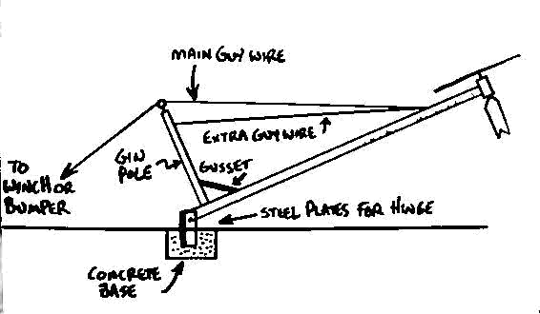

The above diagram shows how a tower can be made simply on solid ground i.e. rock or concrete.
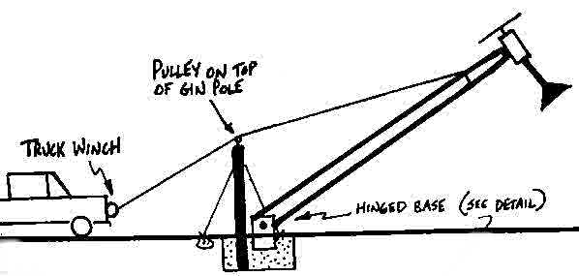
The above diagram shows how a car or a winch can be used to rise and lower a tower for maintenance, being able to lower the tower makes fixing and maintenance easier and much much safer then climbing the tower.

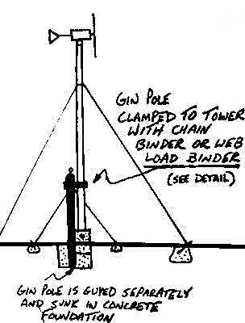
This diagram shows how a tilt up tower is supported once it has been lifted / raised. Due to the soil type at Mr Bigins location I will have to adapt the base to some sort of a weighted box design to replace the concrete. I will do this also because concrete releases CO2 which is a harmful gas which pollutes which goes against Mr Bigins specifications.

